Our Community Library
Matthew Essex and Clayton Greenwell

Project Summary:
This project is designed as a proof-of-concept for a checkout and logging system for small community libraries, often run by volunteers in rural areas and communities; such as those housed by churches, temples, or private communities. The goal is to have a structure which can easily grow while being as low maintenance as possible for the users. While we intend to have a more robust dataset for our demo, this project should ideally scale up or down as needed by the community. It should be easily used by even those with limited to no technical expertise.

Data Description:
Our sample data for this demo is the Project Gutenberg dataset uploaded to Kaggle. The reason we chose this data is that it is a larger than average dataset which should properly stress our design as well help us to normalize it in such a manner that it should be usable on the smaller scale as well. The initial plan is to have three tables, one for Patron Details, one for Books, and one for Transaction Details. The book table will store the book information including publishers, authors, and availability alongside some miscellaneous information used by libraries. The Patron table will store patron information to track who the patrons are, how they could be contacted, and if they have any books checked out. The Transaction log table will be used to track which books have been checked out by who in the past and when they were returned. While this may not seem overly robust, the idea is that it keeps things concise and simple for non-technical users. Below you can see an example of our proposed schema’s rough draft before it has been normalized or had any data loaded in. We expect this to change over the coming weeks as we build the application and test it.
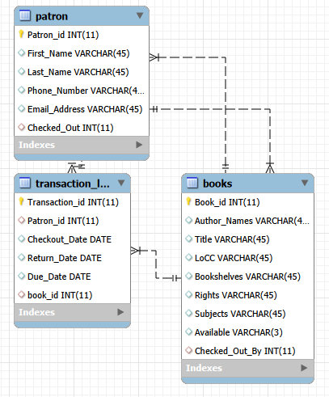

Project Organization
Our team consists of Clayton Greenwell and Matthew Essex. [Clayton’s skills go here] Matthew is an analyst and scrum master by profession, so his focus will be on planning out the project the and focusing on getting things deployed while troubleshooting issues as they arise. We plan to use a relational database built in MySQL Workbench as our backend and use Shiny and python scripts for the frontend and to send the calls to populate and read data from the database. The plan is to setup a github page to share our code and schemas with each other. This will keep a record of the changes and give us rollback should any iteration break the application. Once the database has been fully built and normalized we will begin writing the python code and then bundle the package into one cohesive executable. The timeline for this is not as exact as we would necessarily like because there is a learning curve for working with Shiny as neither member has worked with it before. We plan to have the database built and normalized by March 21st and then to move onto the Python scripts. Ideally the Python work will be done by April 18th which would give us one week of QA testing and recording our video before submitting the final project in for grading.

